
Dance Performance in Mangaung Community
Prepared by: DevCore

Group Members & Roles:
- Tshepang Paballo Mofokeng : Project Manager
- Malefetsane Tabi : Risk Manager
- Luyanda Mfuphi : Communications Officer
- Magaleng Johannes Madike : Financial Controller
- Ranthako Richard Machaea : Content Director
- Mahlale Molefi : Technical Lead
Lecturer: O.P Tsumake
Institution: Central University of Technology
Submission Date : Tuesday ,21 April 2026

- Project Charter(Initiation)

Project Title: Dance Performances in Mangaung Community
Project start date: 20 March 2026 Project end date: 21 April 2026

Budget information: The project budget is R800. Transport fee R300, Data/Internet R200. Printing R100 and Miscellaneous of R200.

Project manager: Tshepang Paballo Mofokeng 24008826@stud.cut.ac.za.

Name | Role | Position | Contact Information
Tshepang  Paballo  Mofokeng | Project Manager | Project coordinator | 224008826@stud.cut.ac.za
Malefetsane Tabi | Risk Manager | Risk Analyst | 224124912@stud.cut.ac.za
Luyanda Mfuphi | Communications  Officer | Communications  Officer | 224053974@stud.cut.ac.za
Project objectives: This project focuses on researching and showcasing dance forms within the Mangaung community. It will combine cultural research with digital media to preserve and promote local dance traditions.
Main Project success criteria: To complete the project within the domain of the triple constraints (scope, time, and cost), while carefully ensuring that that:
- Completion of research on at least 3 dances is completed.
- A functional website is developed.
- At least 3–4 performance videos are uploaded.
- Stakeholder engagement achieved
- Project delivered before 21 April 2026
Approach:
- Identify and document at least three dance styles in Mangaung.
- Research their history, cultural significance, and artistic.
- Create a digital platform(Website) showcasing findings.
- Engage local stakeholders and collect multimedia content.

Magaleng  Johannes  Madike | Financial Controller | Financial Controller | 221023288@stud.cut.ac.za
Ranthako  Richard  Machaea | Content Director | Content Director | 222015743@stud.cut.ac.za
Mahlale Molefi | Technical Lead | Programmer | 224008698@stud.cut.ac.za
O.P Tsumake | Sponsor | Director | otsumake@cut.ac.za

Sign Off: Tshepang and OP
Commence: “Through rhythm, movement, and unity, we bring the stories of Mangaung to life.”
- Stakeholder Register
Stakeholder | Role in Project | Interest | Influence | Communication Method
O.P Tsumake(Lecturer) | Project Sponsor | High | High | In class/Email
DevCore Team Members | Project Team | High | High | WhatsApp Meetings
Dance Groups | Provide interviews & performance | High | Medium | Email
Mangaung Community | Audience | Medium | Medium | In Person
Website Users | View and engage with content | Medium | Low | Website

- Work Breakdown Structure (Planning)
- Initiation
  - Develop Project Charter
  - Identify Stakeholders
- Planning
  - Create WBS
  - Develop Risk Register
  - Develop Quality Plan
  - Create Project Schedule(Gantt Chart)
- Execution
  - Conduct Research on Dance Types
  - Contract Dance Groups
  - Schedule Interviews
  - Record Interviews
  - Record Dance Performances
  - Collect photos and Videos
- Website Development
  - Design Website Layout
  - Create Dance Pages
  - Upload Content
- Monitoring and Control
  - Track Project Progress
  - Update Schedule
  - Manage Risks
- Closing
  - Compile Final Report
  - Prepare Presentation
  - Submit Project

- Project Schedule (Gantt Chart)
- Risk Register

Risk | Impact | Mitigation
No access to dancers | High | Contract multiple groups
Poor internet | Medium | Work offline & upload later
Time constraints | High | Follow schedule strictly
Equipment failure | Medium | Use backup devices
Lack of permissions | High | Get consent forms early
Poor quality videos/audio recording | Medium | Test equipment before filming.  Record multiple takes.
Team members not completing tasks | High | Assign clear responsibilities.  Set deadlines and monitor progress.
Website technical issues | Medium | Use simple platforms.  Save backups of content.
Loss of data (video or photos) | High | Save copies on multiple devices.
Miscommunication within the team. | Medium | Use one main communication platform.

- Communication Plan
Stakeholder | Information Shared | Method | Frequency | Responsible
DevCore Team | Task updates, progress ,deadlines and responsibilities | WhatsApp/Meetings | Daily | Project Manager
Lecturer | Issues/Project Progress | Email/in class | As needed | Project Manager
Dance Groups | Permissions and scheduling interviews | Email | As needed | Communications Officer
Website Users | Project content, dance information | Website | Continuous | Technical Lead
Mangaung Community | Awareness of project and cultural content | Website/Social Media | Continuous | Content Director
Effective communication will be maintained throughout the project to ensure all stakeholders are informed, aligned and able to contribute to the successful completion of the project.
- Quality Plan
Quality Objectives:
- Ensure accurate and well researched information on all dance types.
- Produce clear, high quality videos and images.
- Develop a functional and user friendly website.
- Ensure all links and media work correctly.
Quality Standards:
- Information must be relevant and factually correct.
- Video must have clear audio and visuals.
- Website must be easy to navigate.
- Content must be well organized and professional.
Quality Control Measures:
- Review all content before uploading.
- Test videos, links, and website functionality.
- Get feedback from group members.
- Make corrections where necessary.
- Execution Evidence
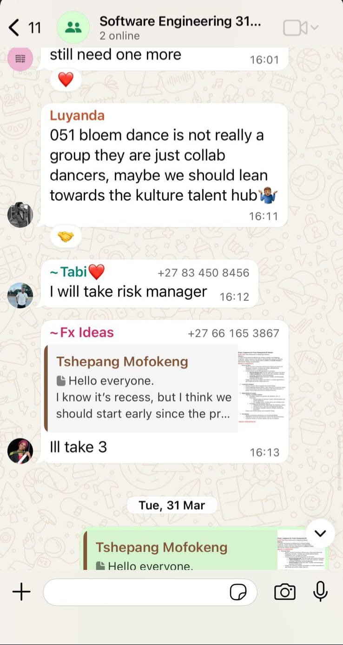
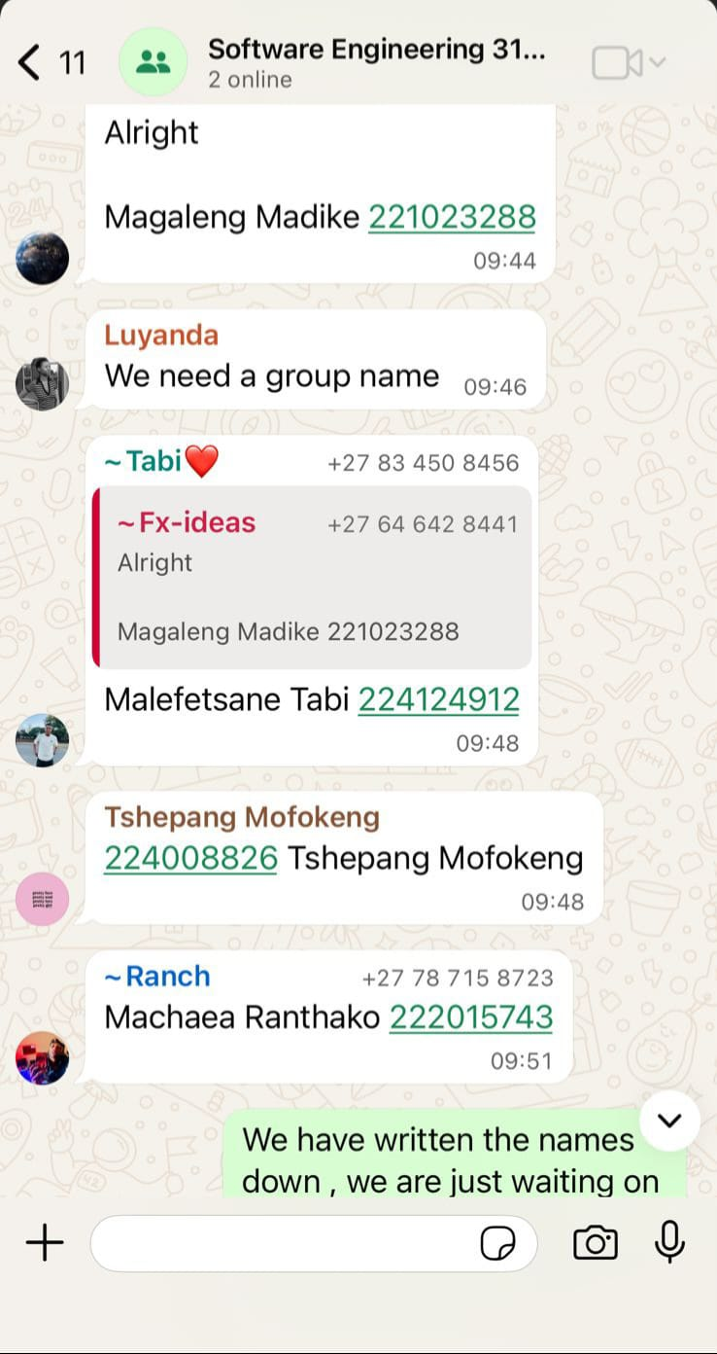

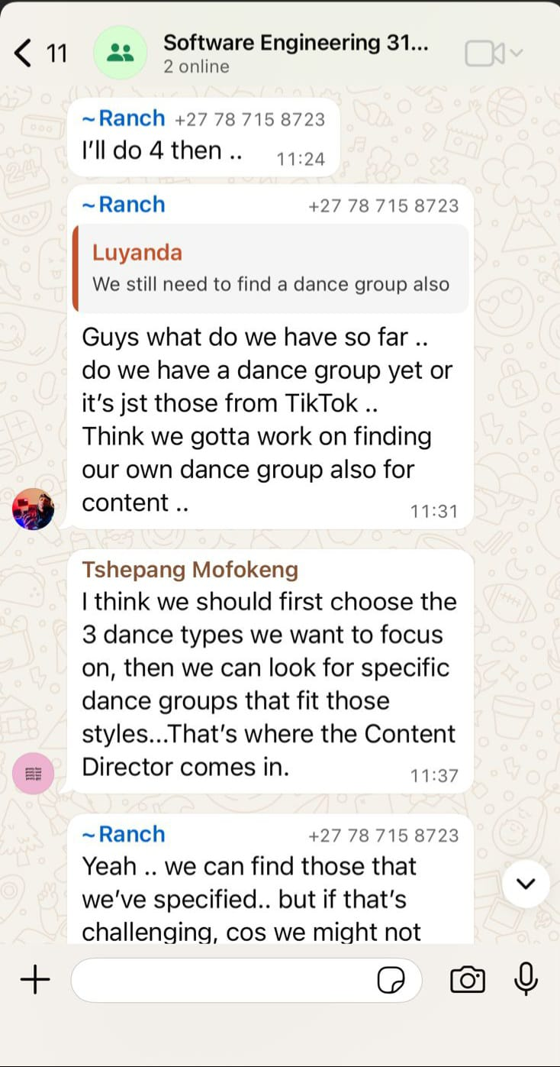
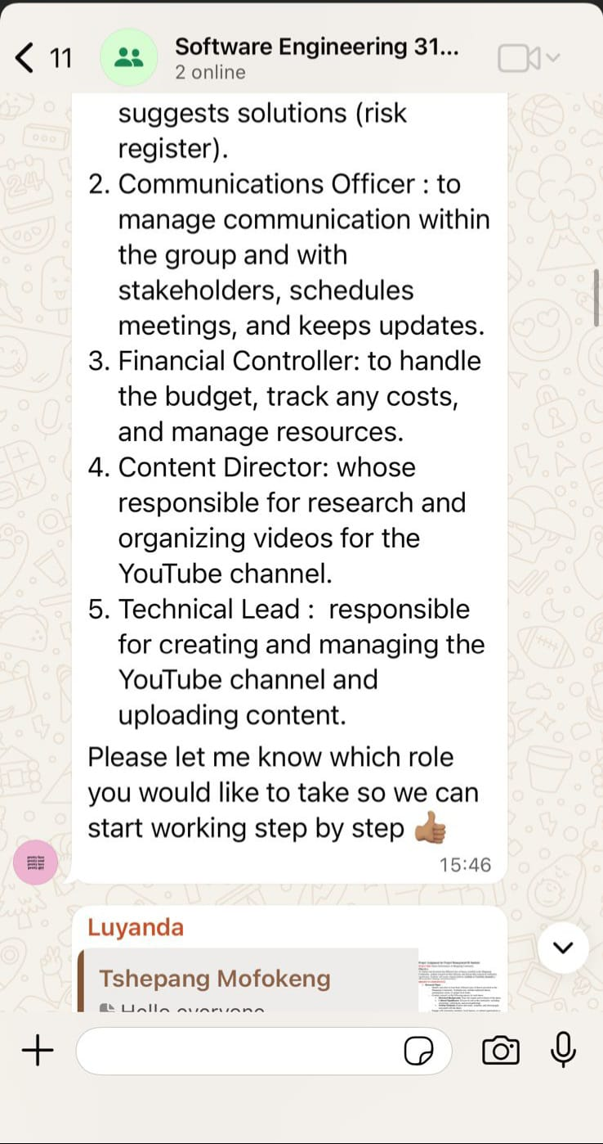
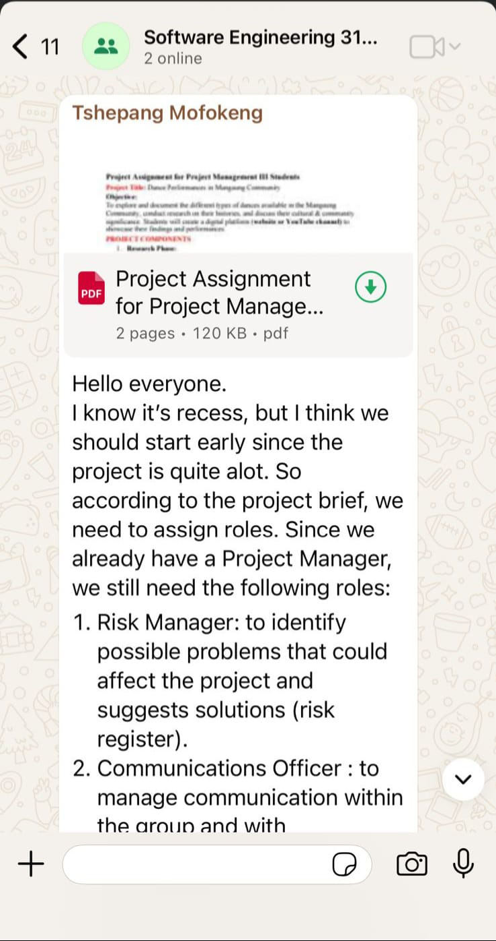
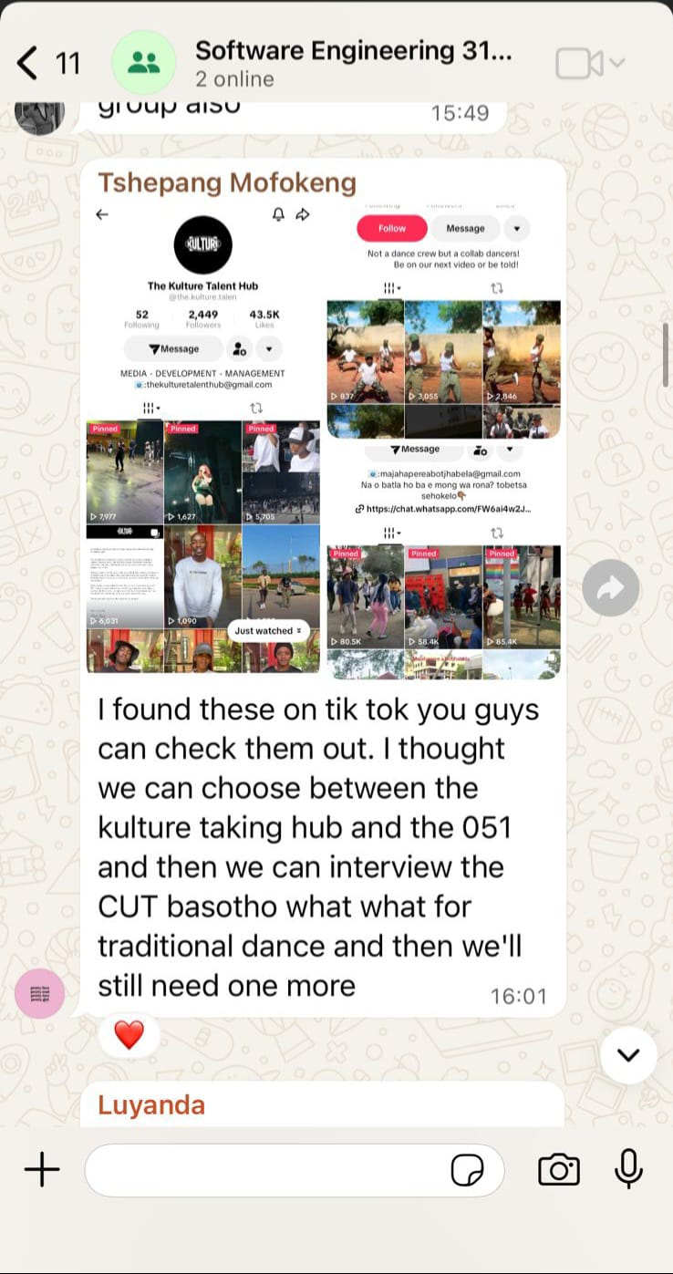
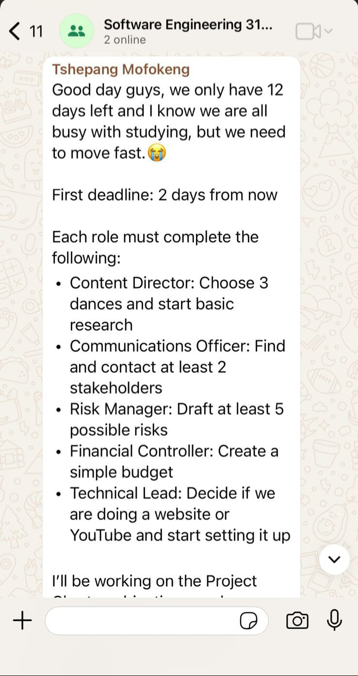
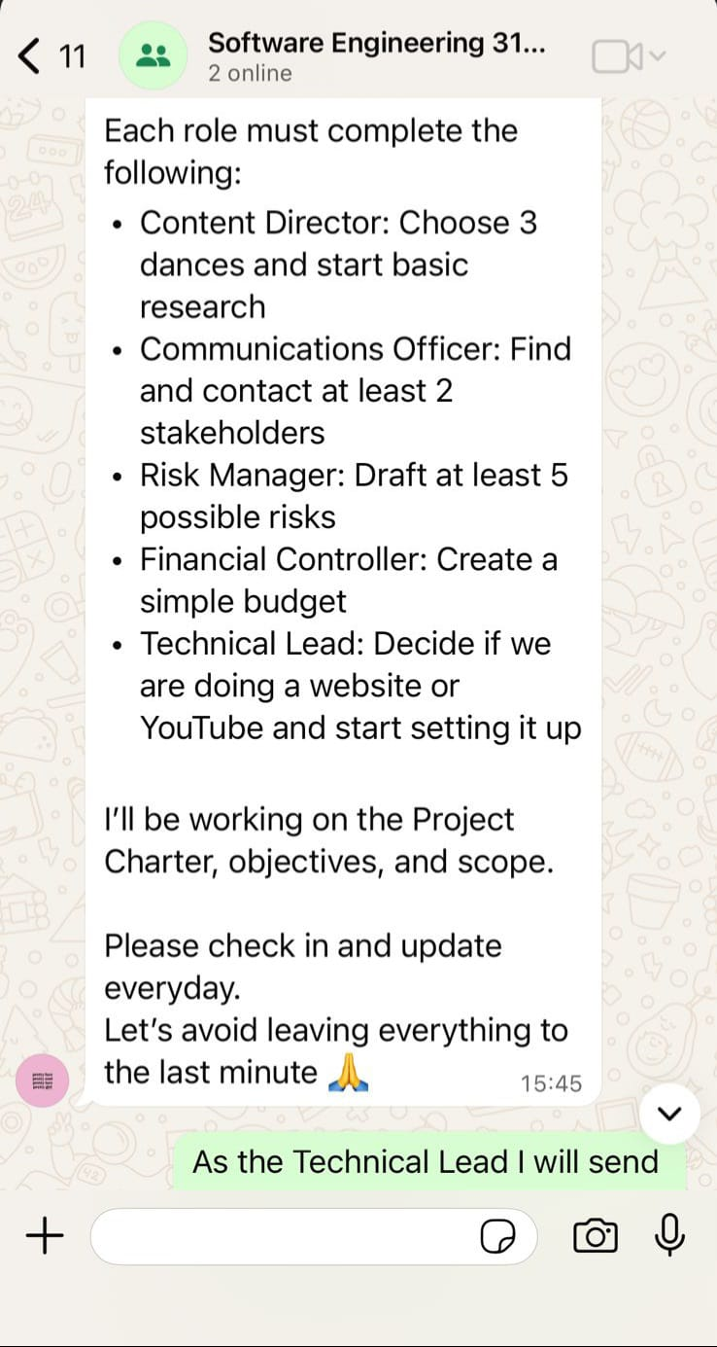
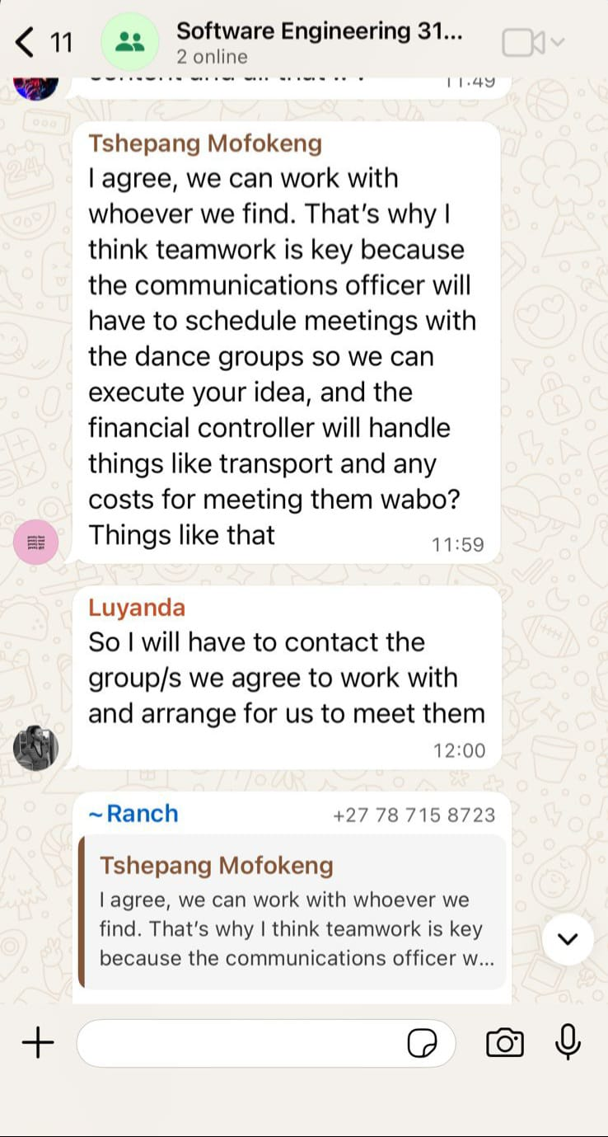
Figure 1: Communication with group members regarding task allocation
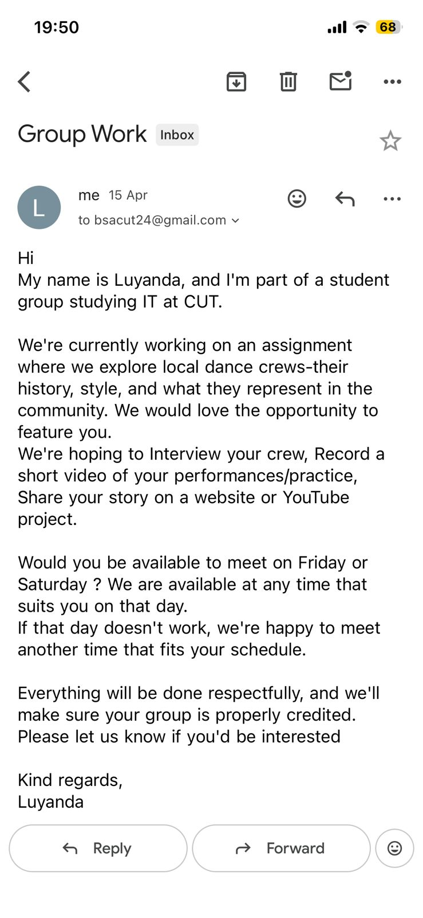
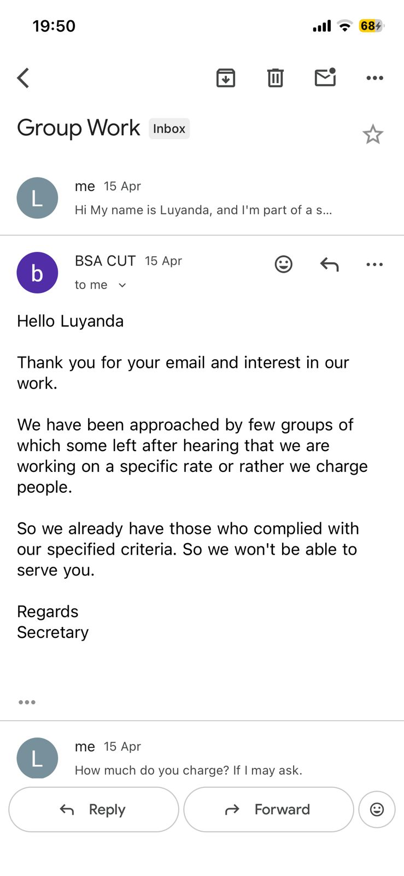
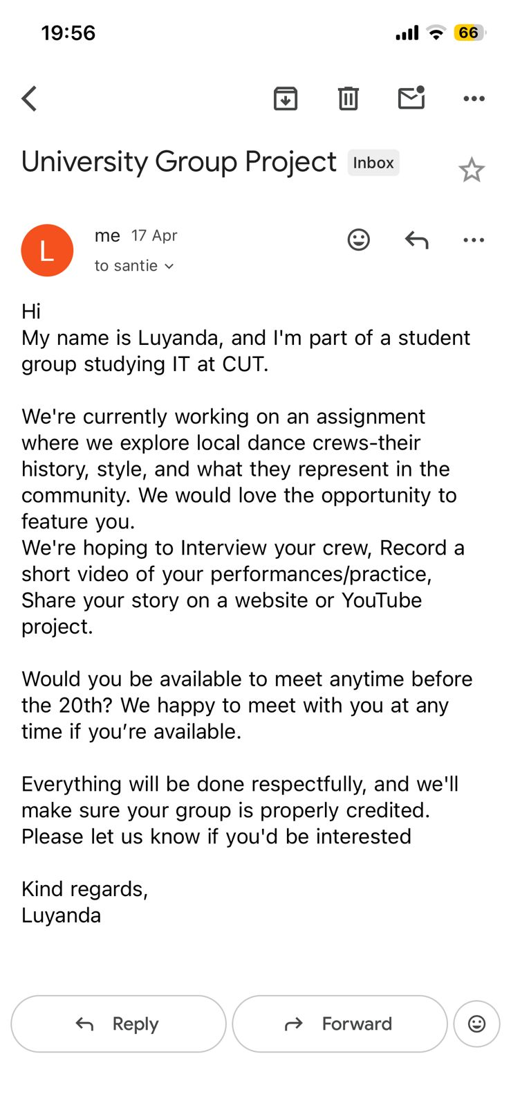
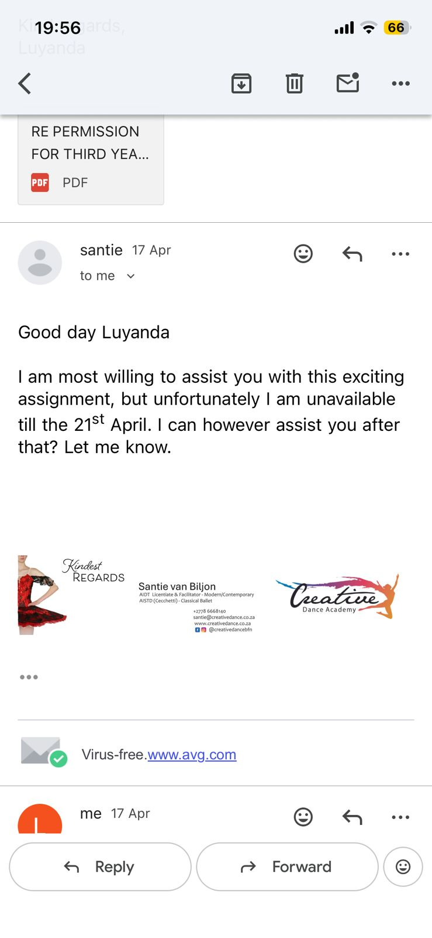
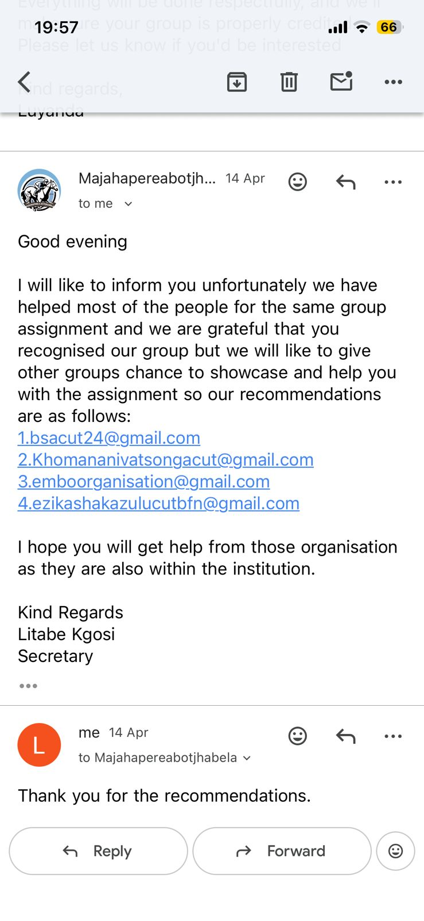
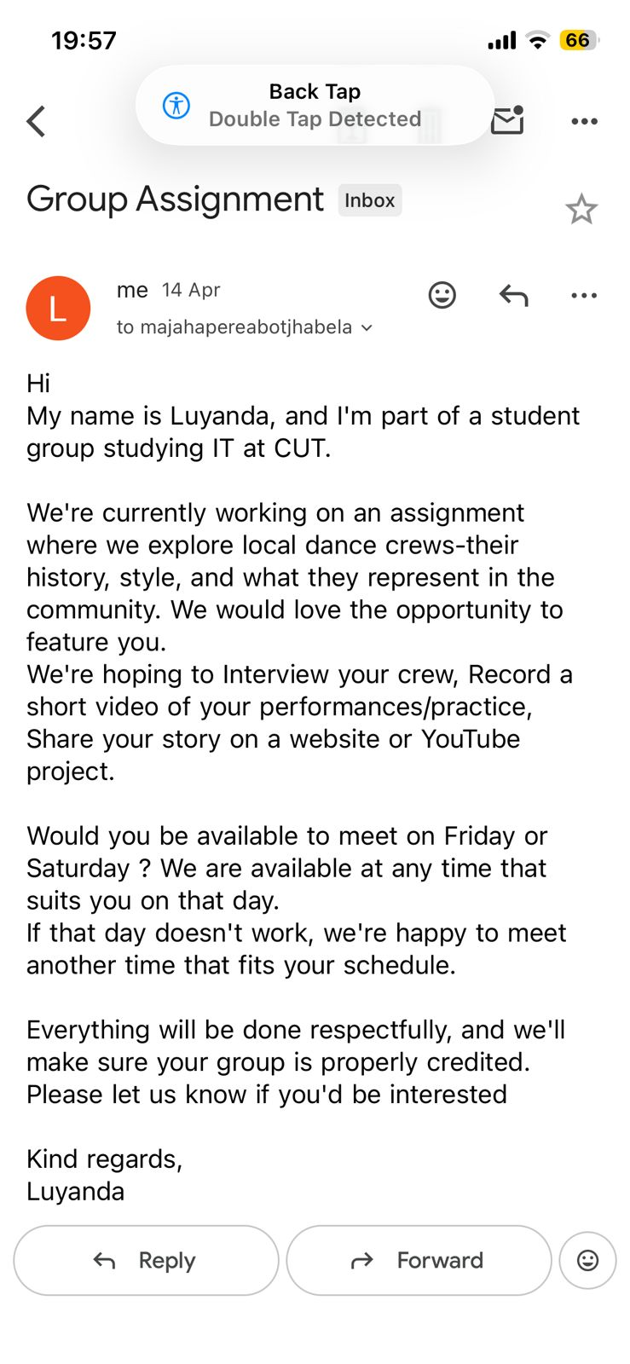
Figure 2: Communication with dance group to arrange interview and filming
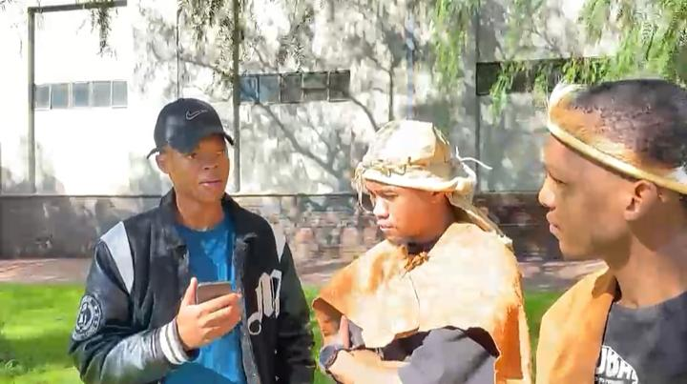
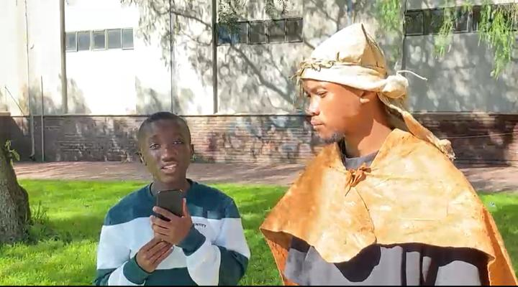
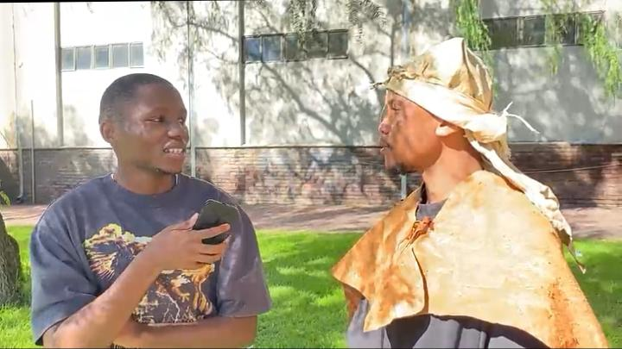
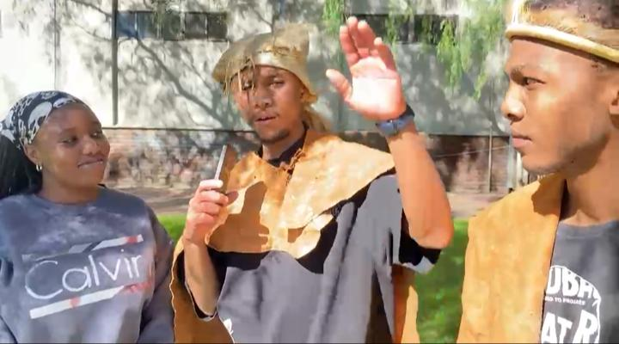
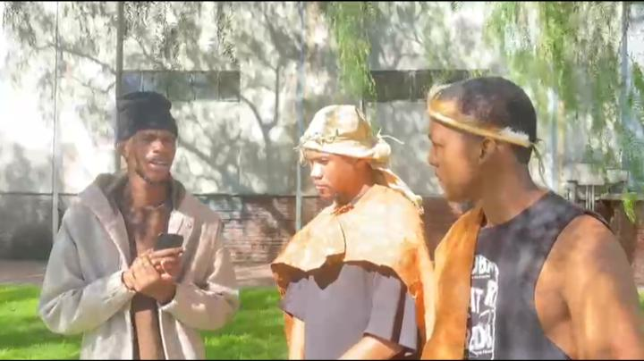

Figure 3: Conducting interview with Tswana dance group

- Monitoring & Control
Progress Monitoring:
- Regular communication was maintained through WhatsApp to track daily progress.
- Tasks were assigned and followed up by the project manager.
- Team members provided updates on their responsibilities.
Schedule Control:
- The project timeline was reviewed and adjusted when necessary.
- Tasks were completed in parallel to meet the deadline.
- Delays in response from dance groups were managed by implementing backup plans.
Risk Monitoring:
- Identified risks were continuously reviewed.
- Team members communicated any issues immediately.
- Mitigation strategies were applied where needed.
Evidence of Monitoring:
- Updates on task completion.
- Website development progress.

- Closing Report & Lessons Learned
Project Summary: The project focused on exploring and documenting different dance styles within the Mangaung community, including Tswana Dance, Famo and Mohobelo . The team successfully combined research and practical engagement by conducting interviews and recording performances. A digital platform was developed to present the findings in a structured and engaging way. Overall, the project was completed within the given timeframe.
Objectives Achieved:
- Developed a functional website.
- Compiled and organized all project documentation.
- Collected multimedia content (videos and images).
- Identified and researched multiple dance types
Challenges Faced:
- Limited time to complete all project requirements.
- Delays in responses from some dance groups.
- Scheduling conflicts for interviews and filming.
Solutions Implemented:
- Divided tasks among team members to improve efficiency.
- Used backup plans when stakeholders were unavailable.
- Conducted tasks in parallel to meet deadlines.
Lessons Learned:
- Effective communication is essential for team coordination.
- Time management is critical in meeting deadlines.
- Team collaboration improves productivity and results.
Team Reflection: The DevCore team worked collaboratively to complete the project despite challenges. Each member contributed to their assigned roles, and consistent communication ensured that progress was maintained. The project provided valuable experience in project management, teamwork, and community engagement.

